**Abstract**

“Payroll Management System” is designed to make the existing manual system automatic with the help of computerised equipment and full-edged computer software, fulfilling their requirements, so that their valuable data and information can be stored for a longer period with easy access and manipulation of the same. The required software is easily available and easy to work with. This web application can maintain and view computerised records without getting redundant entries. The project describes how to manage user data for good performance and provide better services for the client.

**Introduction**

The proposed project “Payroll Management System” has been developed to overcome the problems faced in the practicing of manual system. This software is built to eliminate and in some cases reduce the hardships faced by the existing system. Moreover this system is designed for particular need of the company to carry out its operations in a smooth and effective manner. This web application is reduced as much as possible to avoid errors while entering data. It also provides error message while entering invalid data. It is user-friendly as no formal knowledge is required to use the system. Human resource challenges are faced by every organization which has to be overcome by the organization. Every organization has different employee and payroll management needs. Therefore I have design exclusive Employee and payroll Management System that are adapted to the organization’s Managerial Requirements.

**Purpose**

The purpose of this document is to describe the functionality and specifications of the design of a web application for Managing Employees and their payroll. The expected audiences of this document are the developers and the admin of the web application. Now with the help of this system the admin has the information on his finger tips and can easily prepare a good record based on their requirements. Finally, we can say that this system will not only automate the process but save the valuable time of the manager or the admin, which can be well utilized buy his institute. This will be an additional advantage and management of power based on their free time from his normal duty

**Existing System**

The present calculation of the salary is done manually and it takes a lot of time to compose the employee’s salary. The salary slip also takes a long time to create and as this is a tiresome and cumbersome process it takes a lot of time.

It also delays the salary distribution system. Sometimes the salary is not generated within the stipulated time period thus creating a lot of hassle.

Error is the other major problem of the manual system and even with repeated cross check some of the other errors surely persist which can cause a lot of problems.

To solve this problem the organization need an ideal software that can take care of  all these.

**PURPOSE OF THE SYSTEM**

A payroll system is software designed to organize all the tasks of employee

payment and the filing of employee taxes. These tasks can include keeping track of hours, calculating wages, withholding taxes and deductions, printing and delivering checks and paying employment taxes to the government.

Payroll software often requires very little input from the employer. The employer is required to input employee wage information and hours—then the software calculates the information and performs with-holdings automatically. Most payroll software is automatically updated whenever a tax law changes and will remind employers when to file various tax forms.

**Proposed System**

The new proposed Payroll Management system will surely eradicate all these issues that they are facing now and this software is created in such a manner that it automatically generate the salary of the employees every month without any worries.

This software also keeps a track of the employees payslip and payroll summary.

**System Requirements**

**Tools/Platform:**

* WAMP/XAMP Server
* Note Pad++

**Front-end:**

* PHP
* HTML/Css/Boostrap

**Back-end:**

* MySql Database.

**Software Requirement:**

* Computer(4GB RAM and 50GB ROM)
* Printer

**Flow Chart:**

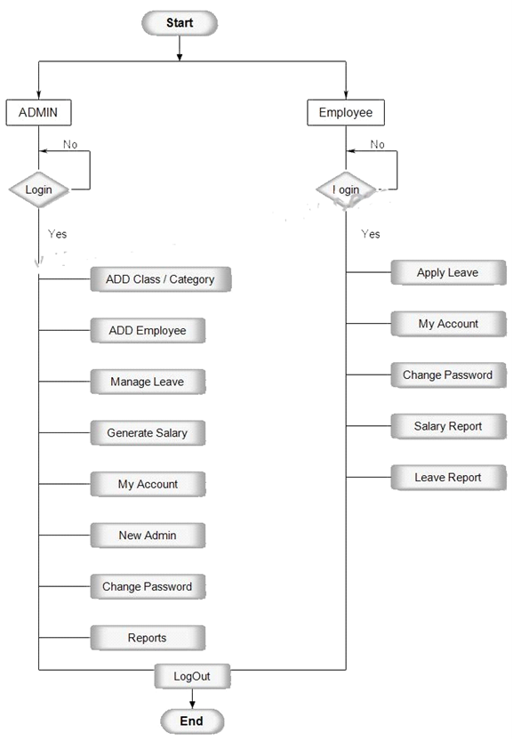

**DataFlow Diagram**

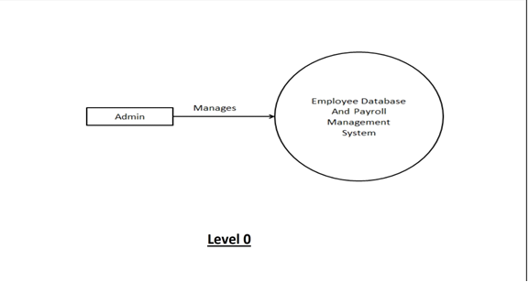

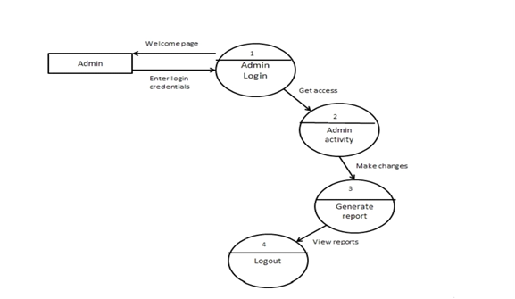

**LEVEL 1**

**SCEENSHOT:**

**Employee :-**

**Index page**

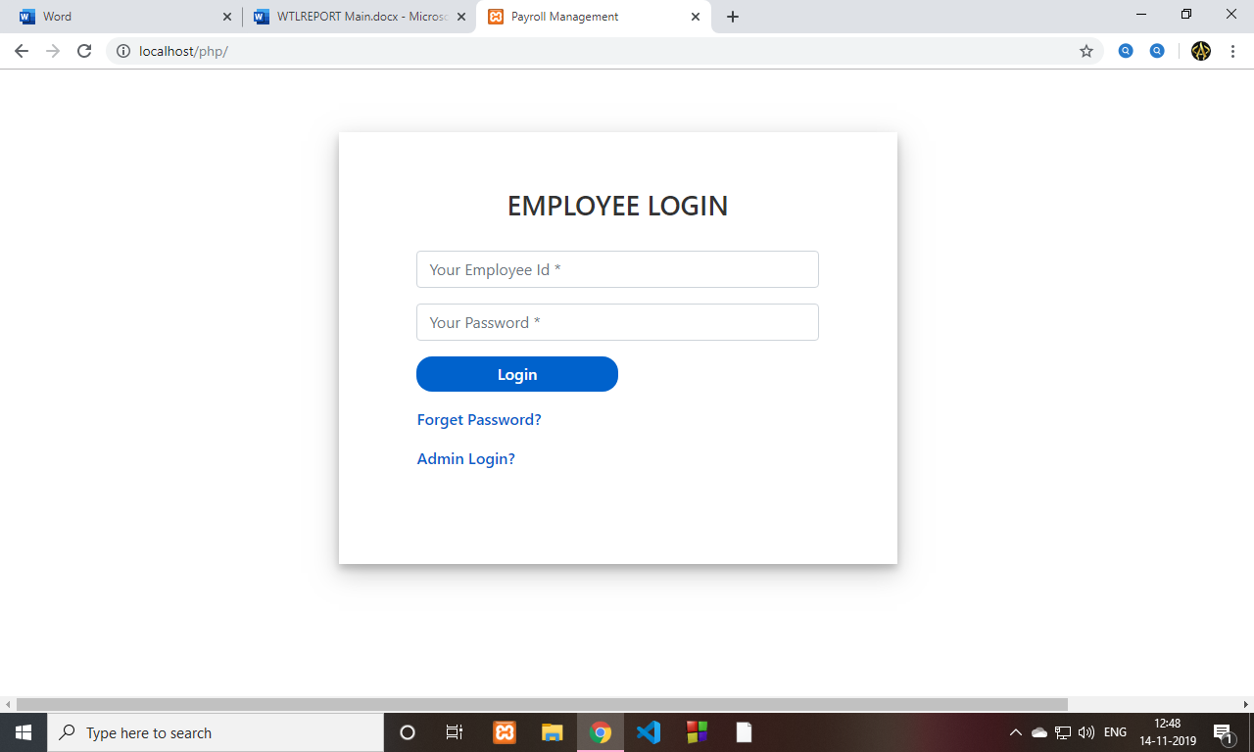

**Home page**



**Payslip**

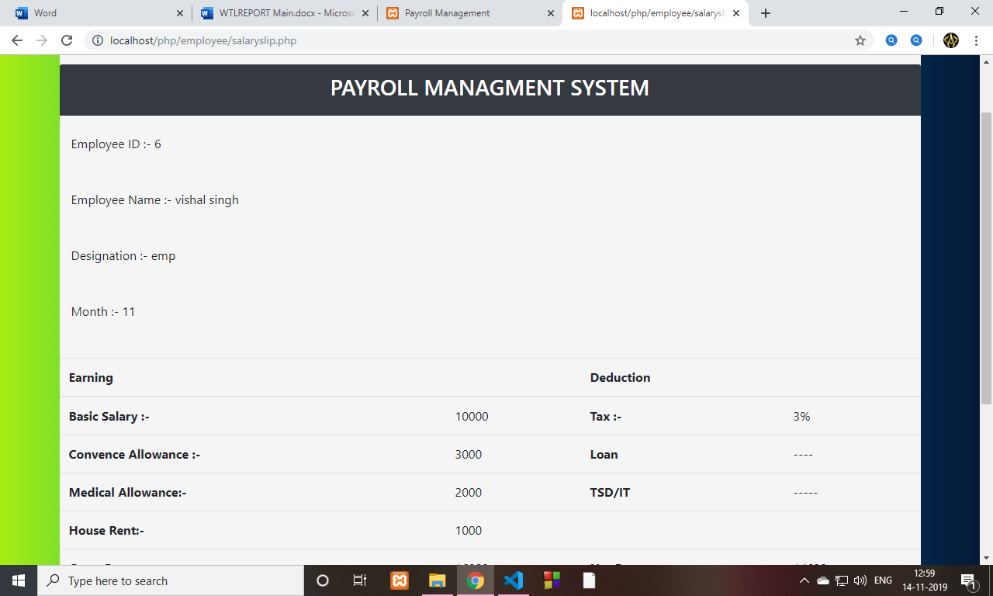

**Profile page**

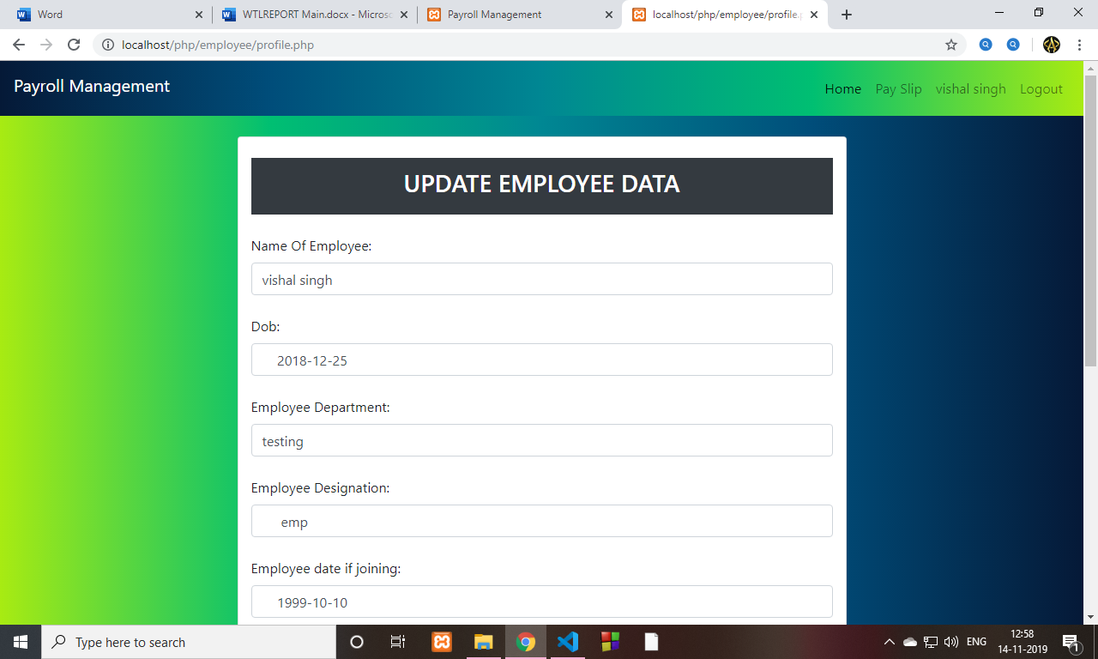

**Admin**

**Login page**

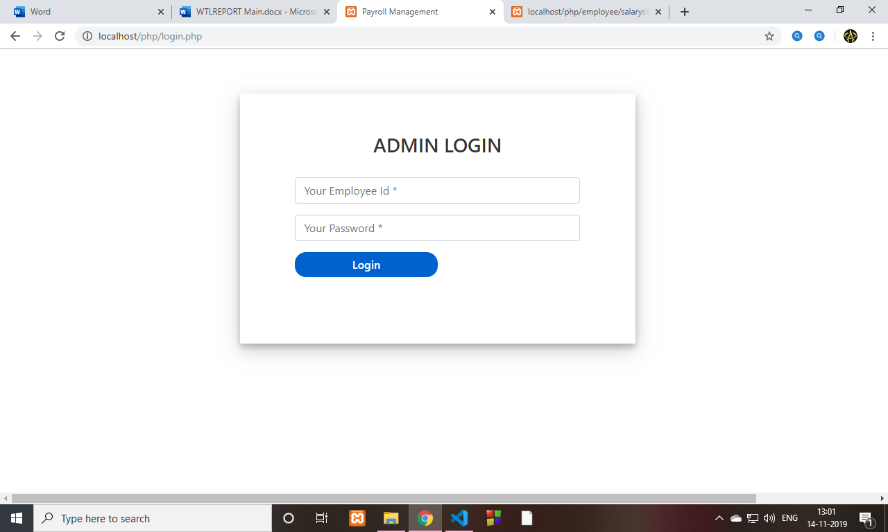

**Home page**

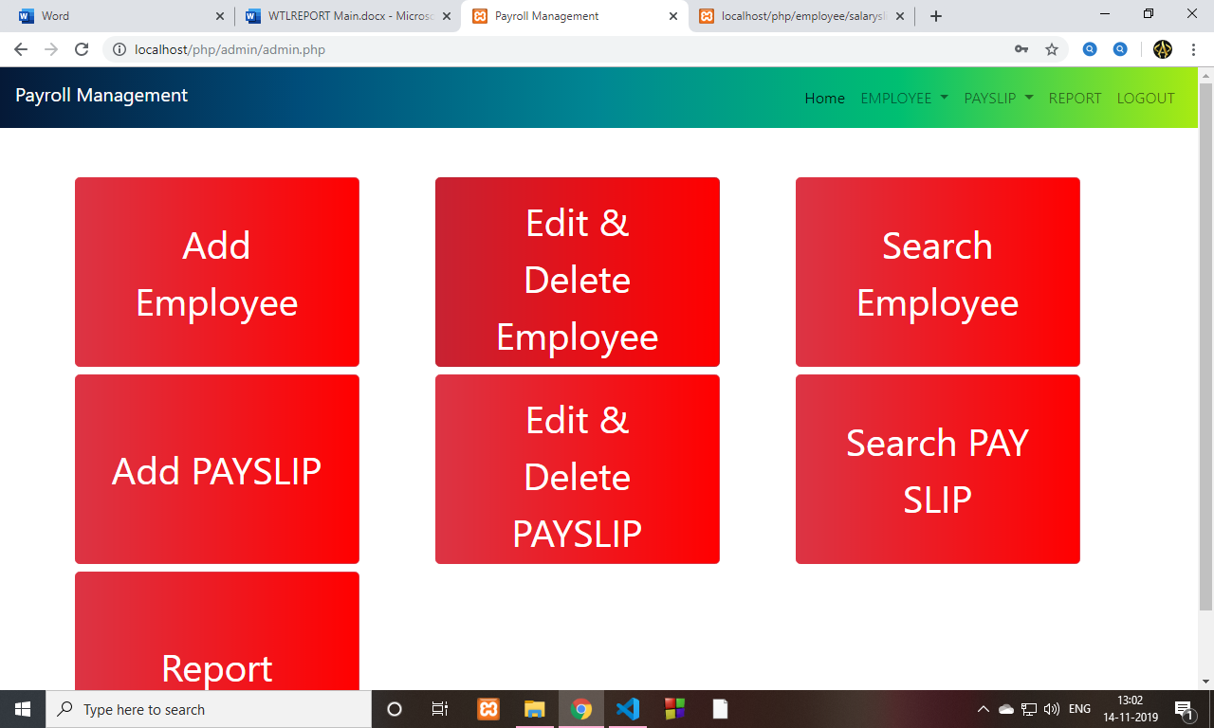

**Add Employee**

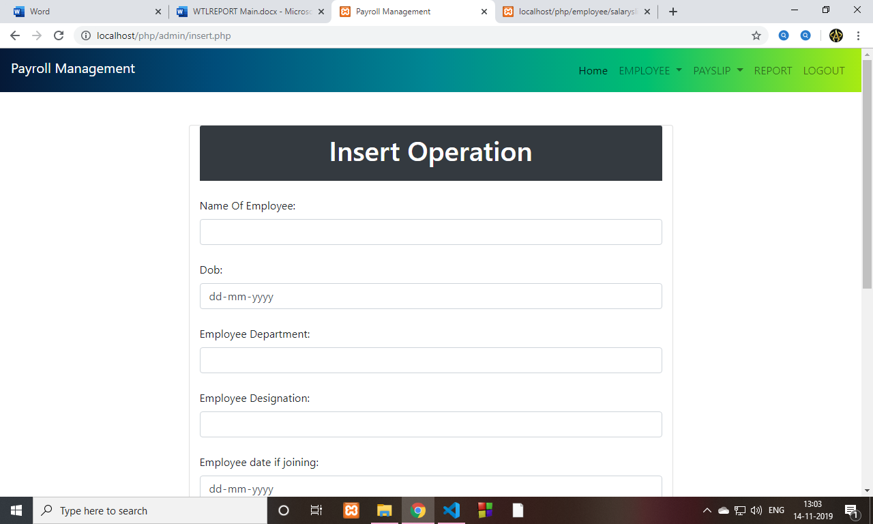

**Delete and Upadte emp records**

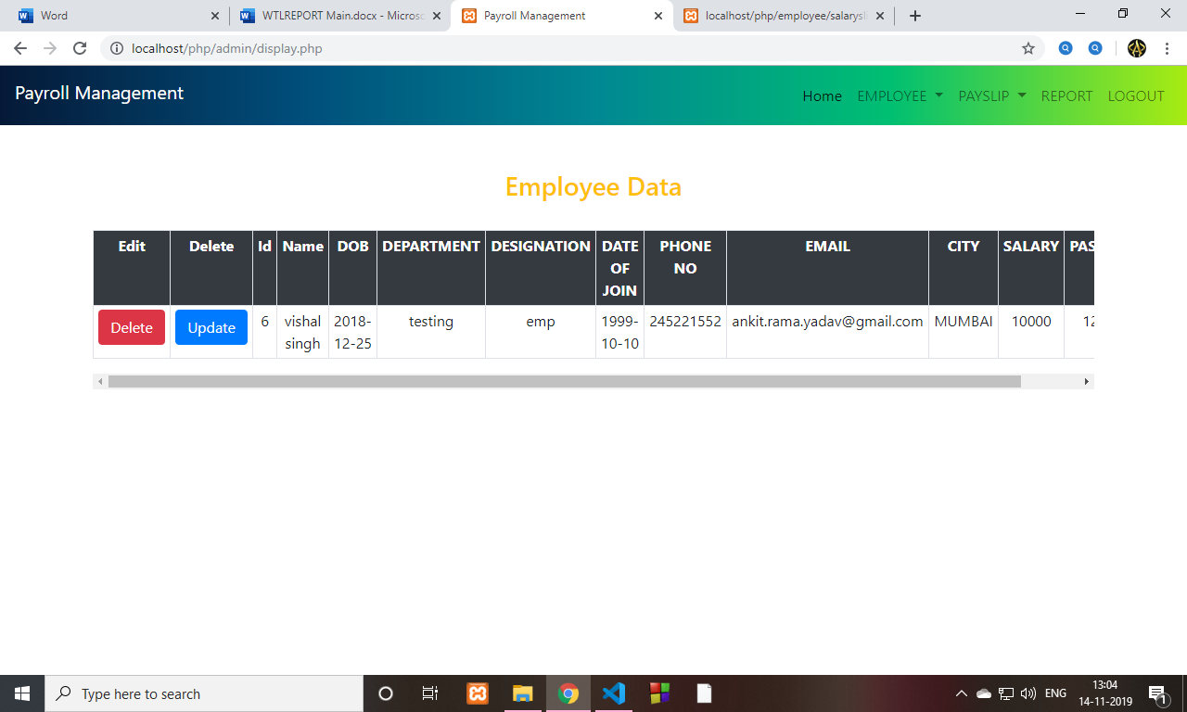

**Add salary Slip**

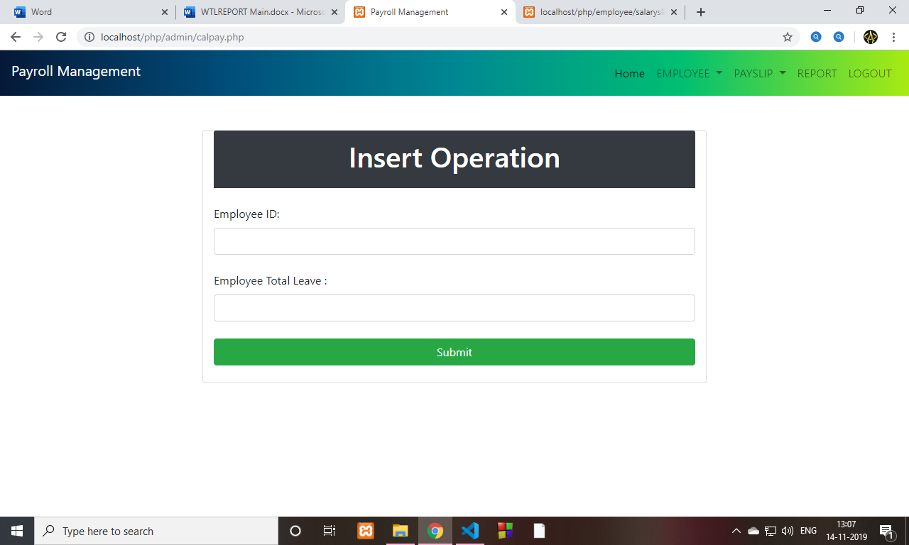

**Delete And Update Payslip**

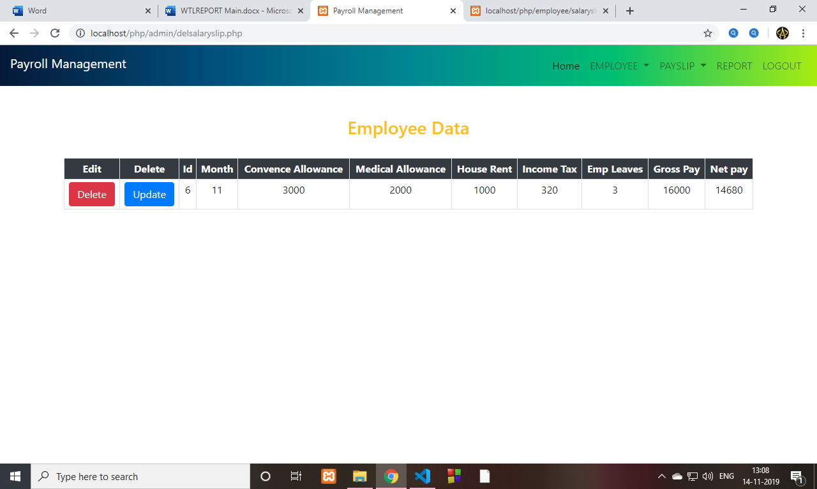

**Report**

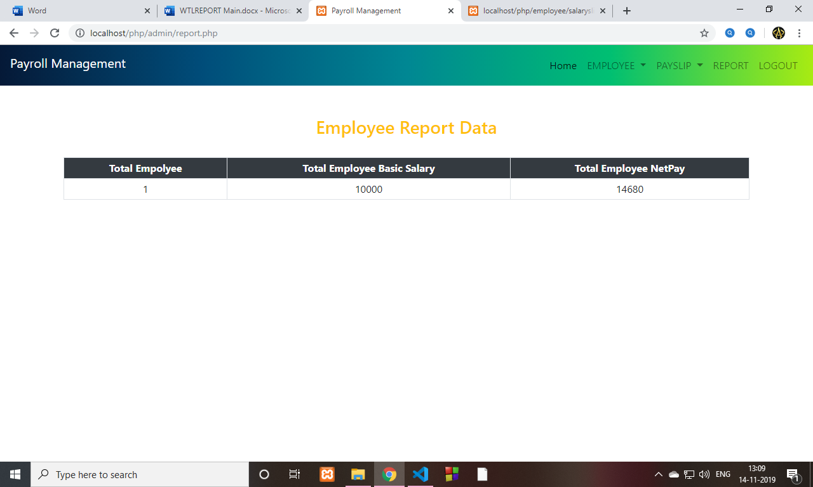

**CODE**

**Empolyee :**

**Home page**

<?php

// Start the session

error_reporting(0);

session_start();

include 'master.php';

?>

<!DOCTYPE html>

<html xmlns="http://www.w3.org/1999/xhtml">

<head runat="server">

<title>Payroll Management</title>

<style>

.btn-lg {

padding: 15px 32px;

text-align: center;

font-size: 50px;

margin: 4px 2px;

cursor: pointer;

}

</style>

</head>

<body>

<form action="slip.php" method="post">

<div class="container">

<br>

<br>

<h1 class="text-white text-center"> Welcome <?php echo $_SESSION["name"]; ?><br>

<br>

<br>

<br>

<button type="button" class="btn btn-danger btn-lg" name="done"><a href="slip.php" class="text-white"> SEE YOUR PAY SLIP</a></button>

</div>

</form>

</body>

</html>

Profile page

<?php

error_reporting(0);

session_start();

include 'conn.php';

include 'master.php';

if(isset($_POST['done'])){

$id = $_SESSION['id'];

$name = $_POST['name'];

$dob = $_POST['dob'];

$Department = $_POST['Department'];

$Designation = $_POST['Designation'];

$dj = $_POST['dj'];

$no = $_POST['no'];

$email = $_POST['email'];

$city = $_POST['city'];

$sal = $_POST['sal'];

$pwd = $_POST['pwd'];

$sql = " update emp set name='$name', dob='$dob', department='$Department',designation=' $Designation',dateofjoin=' $dj',mobailno='$no',email='$email',city='$city',password=' $pwd' where id=$id ";

$con->query($sql);

}

?>

<!DOCTYPE html>

<html>

<head>

<title>Payroll Management</title>

<?php include 'boostrap.php';?>

</head>

<body >

<?php

include 'conn.php';

$id = $_SESSION["id"];

$sql = "select * from emp where id=$id ";

$result = $con->query($sql) or die($con->error);

while($res = $result->fetch_assoc()) {

?>

<div class="container">

<div class="col-lg-8 m-auto">

<form method="post">

<br><div class="card col-lg-12">

<br>

<div class="card-header bg-dark">

<h3 class="text-white text-center"> UPDATE EMPLOYEE DATA </h3>

</div><br>

<label> Name Of Employee: </label>

<input type="text" name="name" value="<?php echo $res['name']; ?>" class="form-control" required="required"> <br>

<label> Dob: </label>

<input type="text" name="dob" value=" <?php echo $res['dob']; ?>"class="form-control" required="required"> <br>

<label>Employee Department: </label>

<input type="text" name="Department"value="<?php echo $res['department']; ?>" class="form-control" required="required"> <br>

<label>Employee Designation: </label>

<input type="text" name="Designation" value="<?php echo $res['designation']; ?>" class="form-control" required="required"> <br>

<label>Employee date if joining: </label>

<input type="text" name="dj" value="<?php echo $res['dateofjoin']; ?>" class="form-control" required="required"> <br>

<label>Employee mobail no: </label>

<input type="text" name="no" value="<?php echo $res['mobailno']; ?>" class="form-control" required="required"> <br>

<label>Employee email: </label>

<input type="text" name="email" value="<?php echo $res['email']; ?>" class="form-control" required="required"> <br>

<label>Employee city: </label>

<input type="text" name="city" value="<?php echo $res['city']; ?>" class="form-control" required="required"> <br>

<label>Employee basic salary: </label>

<input type="text" name="sal" value="<?php echo $res['basicsalary']; ?>" class="form-control" required="required"> <br>

<label>Employee password: </label>

<input type="password" name="pwd" value="<?php echo $res['password']; ?>" class="form-control" required="required"> <br>

<button class="btn btn-success" type="submit" name="done"> Update </button><br>

<?php

}

?>

</div>

</div>

</form>

</div>

</body>

</html>

Salary slip page

<?php

if(isset($_SESSION["id"])) {

echo '<script type="text/javascript">

window.location = "<http://localhost:8080/php/>"

</script>';

}

?>

<?php

error_reporting(0);

session_start();

include 'conn.php';

include 'master.php';

if(isset($_POST['done'])){

$id = $_SESSION['id'];

$month = $_POST['month'];

$_SESSION['m']=$month;

$sql1 = "SELECT month FROM salaryslip WHERE id = $id";

$result1 = $con->query($sql1) or die($con->error);

while($res1 = $result1->fetch_assoc()) {

$check=$res1['month'];

}

if($month==$check)

{

echo '<script type="text/javascript">

window.location = "<http://localhost:8080/php/employee/salaryslip.php>"

</script>';

}

else{

echo '<script type="text/javascript">';

echo ' alert("This Month Payslip is Not Available !!!")'; //not showing an alert box.

echo '</script>';

}

}

?>

<!DOCTYPE html>

<html lang="en">

<head>

<meta charset="UTF-8">

<meta name="viewport" content="width=device-width, initial-scale=1.0">

<meta http-equiv="X-UA-Compatible" content="ie=edge">

<title>Payroll Management</title>

<?php include 'boostrap.php'; ?>

<style>

.container-bg {

background: #F5F5F5;

}

</style>

</head>

<body >

<div class="container">

<div class="col-lg-8 m-auto">

<form method="post">

<br><div class="card col-lg-12">

<br>

<div class="card-header bg-dark">

<h3 class="text-white text-center"> Month Of Pay Slip </h3>

</div><br>

<label> Enter Month Number: </label>

<input type="number" maxlength="2" name="month" class="form-control" required="required"> <br>

<button class="btn btn-success" type="submit" name="done"> Get Pay Slip </button><br>

<br>

</div>

</div>

</div>

</form>

</body>

</html>

**Admin**

Home page

<?php

error_reporting(0);

?>

<!DOCTYPE html>

<html xmlns="http://www.w3.org/1999/xhtml">

<head runat="server">

<title>Payroll Management</title>

<?php

include 'header1.php';

?>

<style>

.btn-lg {

padding: 15px 32px;

text-align: center;

width:300px;

height:200px;

font-size: 40px;

margin: 4px 2px;

cursor: pointer;

background-image: linear-gradient(to right, rgba(255,0,0,0), rgba(255,0,0,1));

}

</style>

</head>

<body>

<?php include 'header.php';?>

<div class="container">

<br><br>

<div class="row">

<div class="col-4"><button type="button" class="btn btn-danger btn-lg"><a href="insert.php" class="text-white"> Add Employee</a></button>

</div>

<div class="col-4"><button type="button" class="btn btn-danger btn-lg"><a href="display.php" class="text-white"> Edit & Delete Employee</a></button>

</div>

<div class="col-4"><button type="button" class="btn btn-danger btn-lg"><a href="search.php" class="text-white"> Search Employee</a></button>

</div>

</div>

<div class="row">

<div class="col-4"><button type="button" class="btn btn-danger btn-lg"><a href="calpay.php" class="text-white"> Add PAYSLIP</a></button>

</div>

<div class="col-4"><button type="button" class="btn btn-danger btn-lg"><a href="delsalaryslip.php" class="text-white"> Edit & Delete PAYSLIP</a></button>

</div>

<div class="col-4"><button type="button" class="btn btn-danger btn-lg"><a href="searchsalaryslip.php" class="text-white"> Search PAY SLIP</a></button>

</div>

</div>

<div class="row">

<div class="col-4"><button type="button" class="btn btn-danger btn-lg"><a href="report.php" class="text-white">Report</a></button>

</div>

</div>

<div>

</body>

</html>

Add employee

<?php

error_reporting(0);

include 'conn.php';

if (isset($_POST['done'])) {

$name = $_POST['name'];

$dob = $_POST['dob'];

$Department = $_POST['Department'];

$Designation = $_POST['Designation'];

$dj = $_POST['dj'];

$no = $_POST['no'];

$email = $_POST['email'];

$city = $_POST['city'];

$sal = $_POST['sal'];

$pwd = $_POST['pwd'];

$sql = "INSERT INTO `emp` (`name`, `dob`, `department`, `designation`, `dateofjoin`, `mobailno`, `email`, `city`, `basicsalary`, `password`) VALUES('$name', '$dob','$Department','$Designation','$dj ','$no','$email','$city',' $sal','$pwd' )";

if ($con->query($sql) === TRUE) {

echo '<script type="text/javascript">';

echo ' alert("New record created successfully")'; //not showing an alert box.

echo '</script>';

} else {

echo "Error: " . $sql . "<br>" . $con->error;

}

}

?>

<!DOCTYPE html>

<html>

<head>

<title>Payroll Management</title>

<?php include 'header1.php';?>

</head>

<body>

<?php include 'header.php';?>

<div class="container">

<div class="col-lg-8 m-auto">

<form method="post">

<br><br>

<div class="card col-lg-12">

<div class="card-header bg-dark">

<h1 class="text-white text-center"> Insert Operation </h1>

</div><br>

<label> Name Of Employee: </label>

<input type="text" name="name" class="form-control" required="required"> <br>

<label> Dob: </label>

<input type="date" name="dob" class="form-control" required="required"> <br>

<label>Employee Department: </label>

<input type="text" name="Department" class="form-control" required="required"> <br>

<label>Employee Designation: </label>

<input type="text" name="Designation" class="form-control" required="required"> <br>

<label>Employee date if joining: </label>

<input type="date" name="dj" class="form-control" required="required"> <br>

<label>Employee mobail no: </label>

<input type="number" maxlength="10" name="no" class="form-control" required="required"> <br>

<label>Employee email: </label>

<input type="text" name="email" class="form-control" title="Contact's email (format: [xxx@xxx.xxx](mailto:xxx@xxx.xxx))" pattern="^([a-zA-Z0-9_\-\.]+)@([a-zA-Z0-9_\-\.]+)\.([a-zA-Z]{2,5})$" required="required"> <br>

<label>Employee city: </label>

<input type="text" name="city" class="form-control" required="required"> <br>

<label>Employee basic salary: </label>

<input type="text" name="sal" class="form-control" required="required"> <br>

<label>Employee password: </label>

<input type="password" name="pwd" class="form-control" pattern="^\S{6,}$" title="Enter atleast 7 Numbers" required="required"> <br>

<button class="btn btn-success" type="submit" name="done"> Submit </button><br>

</div>

</form>

</div>

</body>

</html>

Delete And Update Employee

<?php

error_reporting(0);

?>

<!DOCTYPE html>

<html>

<head>

<title>Payroll Management</title>

<?php include 'header1.php';?>

</head>

<body>

<?php include 'header.php';?>

<br><br>

<h3 class="text-warning text-center" > Employee Data </h3><br>

<div class="container">

<div class="col-lg-12">

<div class="table-responsive">

<table id="tabledata" class=" table table-striped table-hover table-bordered table-sm">

<tr class="bg-dark text-white text-center">

<th> Edit </th>

<th> Delete </th>

<th> Id </th>

<th> Name </th>

<th> DOB </th>

<th> DEPARTMENT </th>

<th> DESIGNATION </th>

<th> DATE OF JOIN </th>

<th> PHONE NO </th>

<th> EMAIL </th>

<th> CITY </th>

<th> SALARY </th>

<th> PASSWORD </th>

</tr >

<?php

include 'conn.php';

$sql = "select * from emp ";

$result = $con->query($sql) or die($con->error);

while($res = $result->fetch_assoc()) {

?>

<tr class="text-center">

<td> <button class="btn-danger btn"> <a href="delete.php?id=<?php echo $res['id']; ?>" class="text-white"> Delete </a> </button> </td>

<td> <button class="btn-primary btn"> <a href="update.php?id=<?php echo $res['id']; ?>" class="text-white"> Update </a> </button> </td>

<td> <?php echo $res['id']; ?> </td>

<td> <?php echo $res['name']; ?> </td>

<td> <?php echo $res['dob']; ?> </td>

<td> <?php echo $res['department']; ?> </td>

<td> <?php echo $res['designation']; ?> </td>

<td> <?php echo $res['dateofjoin']; ?> </td>

<td> <?php echo $res['mobailno']; ?> </td>

<td> <?php echo $res['email']; ?> </td>

<td> <?php echo $res['city']; ?> </td>

<td> <?php echo $res['basicsalary']; ?> </td>

<td> <?php echo $res['password']; ?> </td>

</tr>

<?php

}

?>

</div>

</table>

</div>

</div>

<script type="text/javascript">

$(document).ready(function(){

$('#tabledata').DataTable();

})

</script>

</body>

</html>

Add salary Slip

<?php

include 'conn.php';

error_reporting(0);

if (isset($_POST['done'])) {

$id = $_POST['id'];

$month=date('m');

$leave=$_POST['leave'];

$sql1 = "SELECT month FROM salaryslip WHERE id = $id";

$result1 = $con->query($sql1) or die($con->error);

while($res1 = $result1->fetch_assoc()) {

$mo=$res1['month'];

}

if($month == $mo)

{

echo "<script type=\"text/javascript\">alert('Alredy Added tis Month Salary Slip');</script>";;

}

else{

$leave = $_POST['leave'];

$sql = "SELECT basicsalary FROM emp WHERE id = $id";

$result = $con->query($sql) or die($con->error);

while($res = $result->fetch_assoc()) {

$sal=$res['basicsalary'];

}

$ca=3000;

$ma=2000;

$hr=1000;

$gross=$ca+$ma+$hr+$sal;

$day=date('m');

$it=$gross*0.02;

$d=cal_days_in_month(CAL_GREGORIAN,$day,2019);

$d2=$d-$leave;

$d3=$sal/$d;

$r=$d3*$leave;

$r3=round($r,0);

$r1=$gross-$it;

$netpay=$r1-$r3;

$sql = "INSERT INTO `salaryslip` (`id`, `month`, `ca`, `ma`, `ha`, `tax`, `totalleave`, `grosspay`, `netpay`) VALUES('$id ', ' $month','$ca','$ma','$hr ','$it','$leave','$gross',' $netpay' )";

if ($con->query($sql) === TRUE) {

echo '<script type="text/javascript">';

echo ' alert("Salary Slip created successfully")'; //not showing an alert box.

echo '</script>';

} else {

echo "Error: " . $sql . "<br>" . $con->error;

}

}

}

?>

<!DOCTYPE html>

<html>

<head>

<title>Payroll Management</title>

<?php include 'boostrap.php'; ?>

</head>

<body>

<?php include 'header.php';?>

<div class="container">

<div class="col-lg-8 m-auto">

<form method="post">

<br><br>

<div class="card col-lg-12">

<div class="card-header bg-dark">

<h1 class="text-white text-center"> Insert Operation </h1>

</div><br>

<label> Employee ID: </label>

<input type="number" name="id" class="form-control" required="required"> <br>

<label>Employee Total Leave : </label>

<input type="number" name="leave" class="form-control" required="required"> <br>

<button class="btn btn-success" type="submit" name="done"> Submit </button><br>

</div>

</form>

</div>

</body>

</html>

Delete And Update salary slip

<?php

error_reporting(0);

?>

<!DOCTYPE html>

<html>

<head>

<title>Payroll Management</title>

<?php include 'header1.php';?>

</head>

<body>

<?php include 'header.php';?>

<br><br>

<h3 class="text-warning text-center" > Employee Data </h3><br>

<div class="container">

<div class="col-lg-12">

<div class="table-responsive">

<table id="tabledata" class=" table table-striped table-hover table-bordered table-sm">

<tr class="bg-dark text-white text-center">

<th> Edit </th>

<th> Delete </th>

<th> Id </th>

<th> Month </th>

<th> Convence Allowance </th>

<th> Medical Allowance </th>

<th> House Rent </th>

<th> Income Tax</th>

<th> Emp Leaves </th>

<th> Gross Pay </th>

<th> Net pay </th>

</tr >

<?php

include 'conn.php';

$sql = "select * from salaryslip ";

$result = $con->query($sql) or die($con->error);

while($res = $result->fetch_assoc()) {

?>

<tr class="text-center">

<td> <button class="btn-danger btn"> <a href="deletesalary.php?id=<?php echo $res['id']; ?>" class="text-white"> Delete </a> </button> </td>

<td> <button class="btn-primary btn"> <a href="updatesalaryslip.php?id=<?php echo $res['id']; ?>" class="text-white"> Update </a> </button> </td>

<td> <?php echo $res['id']; ?> </td>

<td> <?php echo $res['month']; ?> </td>

<td> <?php echo $res['ca']; ?> </td>

<td> <?php echo $res['ma']; ?> </td>

<td> <?php echo $res['ha']; ?> </td>

<td> <?php echo $res['tax']; ?> </td>

<td> <?php echo $res['totalleave']; ?> </td>

<td> <?php echo $res['grosspay']; ?> </td>

<td> <?php echo $res['netpay']; ?> </td>

</tr>

<?php

}

?>

</div>

</table>

</div>

</div>

<script type="text/javascript">

$(document).ready(function(){

$('#tabledata').DataTable();

})

</script>

</body>

</html>

REPORT

<?php

error_reporting(0);

?>

<!DOCTYPE html>

<html>

<head>

<title>Payroll Management</title>

<?php include 'header1.php';?>

</head>

<body>

<?php include 'header.php';?>

<br><br>

<h3 class="text-warning text-center" > Employee Report Data </h3><br>

<div class="container">

<div class="col-lg-12">

<div class="table-responsive">

<table id="tabledata" class=" table table-striped table-hover table-bordered table-sm">

<tr class="bg-dark text-white text-center">

<th> Total Empolyee </th>

<th> Total Employee Basic Salary </th>

<th> Total Employee NetPay </th>

</tr >

<?php

include 'conn.php';

$sql = "SELECT COUNT(*) as data FROM emp ";

$result = $con->query($sql) or die($con->error);

while($res = $result->fetch_assoc()) {

$data=$res['data'];

}

$sql1 = "SELECT SUM(basicsalary) as saldata FROM emp ";

$result1 = $con->query($sql1) or die($con->error);

while($res1 = $result1->fetch_assoc()) {

$saldata=$res1['saldata'];

}

$sql2 = "SELECT SUM(netpay) as netdata FROM salaryslip ";

$result2 = $con->query($sql2) or die($con->error);

while($res2 = $result2->fetch_assoc()) {

$netdata=$res2['netdata'];

}

?>

<tr class="text-center">

<td> <?php echo $data; ?> </td>

<td> <?php echo $saldata; ?> </td>

<td> <?php echo $netdata; ?> </td>

</tr>

</div>

</table>

</div>

</div>

<script type="text/javascript">

$(document).ready(function(){

$('#tabledata').DataTable();

})

</script>

</body>

</html>

**DATABASE STRUCTURE**

**Emp table**

|  |  |
| --- | --- |
| **Name** | **Type** |
| **id** | **int** |
| **name** | **text** |
| **dob** | **text** |
| **department** | **text** |
| **designation** | **text** |
| **dateofjoin** | **text** |
| **Mobailno** | **text** |
| **email** | **text** |
| **city** | **text** |
| **basicsalary** | **text** |
| **password** | **text** |

**Salaryslip table:**

|  |  |
| --- | --- |
| **name** | **type** |
| **id** | **int** |
| **month** | **varchar** |
| **ca** | **text** |
| **ma** | **text** |
| **ha** | **text** |
| **tax** | **text** |
| **totalleave** | **text** |
| **grosspay** | **text** |
| **netpay** | **text** |

**Future scope of the work:**

* The option to print the records In future.

* I intend to add a leave structure in the future.

* I would like to implement a regular backup mechanism to back up the

employee database to avoid disasters.

* The system can be developed in such a way that its existing features can

be modified to better versions.

**Conclusion:**

This project is built keeping in mind that it is to be used by only one user that is the admin. It is built for use in small scale organization where the number of employees is limited. According to the requested requirement the admin can add, manipulate, update and delete all employee data in his organization. The admin can add new departments and delete them. The Admin can also add predefined pay grades for the employees. The required records can be easily viewed by the admin anytime time he wants in an instant. The payment of the employee is based on monthly basis. Numerous validations implemented would enable the admin to enter accurate data. The main objective of this framework is to save time, make the system cost effective and management records efficiently.

**Reference**

**•** [**www.w3schools.com**](http://www.w3schools.com/)

**•** [**www.tutorialspoint.com**](http://www.tutorialspoint.com/)

**•** [**www.youtube.com**](http://www.youtube.com/)